***FAS DB service accounts***

svc-iacms-fasroapp

svc-ksms-fasroapp

svc-stat-fasroapp

The common password is:  fasFAS#12345

svc-ccsf-fasreadonly

The password is   F@SaCCe$$1

fdapp

The DBA set own password for each system

FAS-PIV development

-78fcd5ba5c16b8ee207a6df87216de44

Development: FASDev#123 First login to DB unix server using putty from your DDD.

Then use sudo su – odbfas, enter your unix password

Then type sqlplus FD/<FD pwd> to login to sqlplus

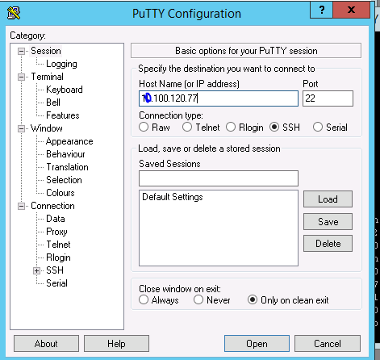

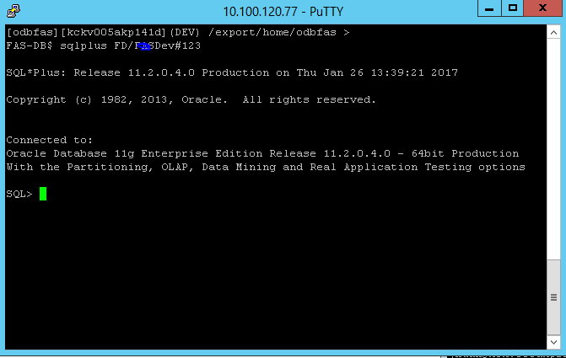

1. Read the AATE Application On-boarding guide
2. FAS-PIV is SP initiated SSO
3. Meet with the F5 team
4. Design, review, and get approved the DFD
5. Map faspiv.tsa.dhs.gov to ITE-PIV server
6. Request OED-Test-Support for Write privilege to ofasapp account
7. Request to install a Win10 VD in ITE jump box xxx.200
8. Obtain and configure DHS Dual Test Card
9. Request TSA-PKT for a code signing certificate for non-production server.
10. Build a keystore using the certificate
11. Submit the certificate
12. Import the certificate
13. Get the IDP metadata from F5 team
14. Implement the FAS-PIV application for a dual login screen
15. Build the application with the IDP metadata and keystore
16. Generate the SP metadata and send it to the F5 along with SP certificate
17. Request OED-Test-Support to link AD email to the PIV card
18. Deploy the application to ITE-PIV server
19. Request F5 IdP to configure the email address in the NameId attribute
20. Conduct a testing session with the F5 IdP
21. Debug the application for correct AuthnRequest and SAMLResponse